For immediate release: 12:30pm, Tuesday 26 May 2015

The Australian Ballet announces China tour program, with confirmed support from government and two new sponsors
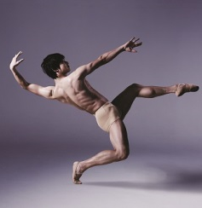 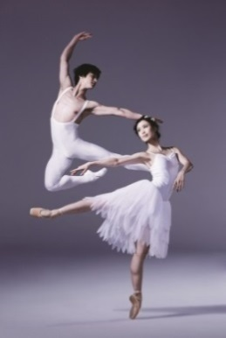 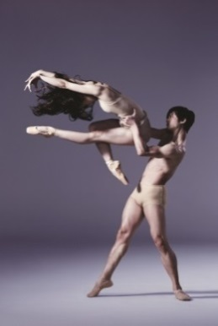

The Australian Ballet’s Chengwu Guo and Ako Kondo (photos Justin Ridler)

The Australian Ballet have today announced the company will tour to Beijing and Shanghai in October 2015, performing programs which include two of the company’s best loved signature works Graeme Murphy’s Swan Lake, Cinderella and a Mixed Bill program at two important and prestigious festivals; National Centre for Performing Arts Dance Festival and Shanghai International Arts Festival.
Speaking at the announcement today at Parliament House, Attorney-General for Australia and Minister for the Arts, the Hon George Brandis QC and Minister for Foreign Affairs the Hon Julie Bishop confirmed the Federal Governments support for this important tour which will contribute funding of $150,000 towards tour costs.
“It is an honour that our national ballet company, The Australian Ballet, has been invited back to China for the 8th time, to participate in such important festivals. I'm confident the company will make all Australians proud as they once again demonstrate their trademark world class performance standards on the international stage,” said Attorney-General for Australia and Minister for the Arts the Hon George Brandis QC.
Minister for Foreign Affairs the Hon Julie Bishop said, “Cultural diplomacy is an important and effective way to develop broader relationships between nations. I'm delighted that The Australian Ballet tour will facilitate this with deeper diplomatic, commercial and cultural alliances between China and Australia.”

Artistic Director David McAllister said, “I am thrilled that The Australian Ballet will once again be performing in China. Since 1980 we have built a fantastic relationship with the Chinese audiences and we look forward to opening the National Centre for Performing Arts Dance Festival (NCPA) in Beijing and being a part of the Shanghai International Arts Festival on this our eighth tour of China.”

“This tour is a great opportunity for us to showcase the distinctive talents of The Australian Ballet – Australia’s national ballet company – in three programs. In Beijing, where we are looking forward to our first performances in the National Performing Arts Centre, our program includes Graeme Murphy’s signature work Swan Lake, the first time this ballet will be performed in Beijing. Shanghai will see the first international performances of Alexei Ratmansky’s unique Cinderella, created for us in 2013. We will also perform a mixed program which showcases the rich versatility of our dancers, in both cities. This program includes Serge Lifar’s Suite en Blanc, Twyla Tharp’s In the Upper Room and Stephen Baynes’ emotional duet Unspoken Dialogues.”

In addition to the support of the Australian Government and The Australian Ballet’s international tour partner, Qantas, this tour is also supported by two important new partners: Chow Tai Fook Jewellery Group Limited, one of the world's largest listed jewellery companies with extensive distribution in Mainland China, Hong Kong and Macau; and Rio Tinto Diamonds, one of the world’s leading diamond producers with a portfolio that includes the iconic Australian Argyle diamond mine.

Alan Davies, Chief Executive of Rio Tinto Diamonds said, “Rio Tinto is delighted to support one of Australia’s great arts organisations. A deep understanding of the arts plays an important role in a sophisticated business like Rio Tinto and a well-rounded society. Our partnership with The Australian Ballet is a logical extension of our partnership approach in China, one of Rio Tinto’s key markets and where we have a history going back over half a century.”

Rio Tinto’s strategic partnership with Chow Tai Fook has resulted in fashion jewellery collaborations using diamonds from the Argyle mine.

Chow Tai Fook Jewellery Ltd Managing Director Kent Wong said, “We are very proud of our five year partnership with Rio Tinto Diamonds and we are delighted to be aligned with another of Australia’s great exports, The Australian Ballet.”

Embarking on such a tour is no small feat. Speaking at the announcement in Canberra, Libby Christie, Executive Director of The Australian Ballet noted that the project involved a touring party of 112 people, including dancers, music, wardrobe, medical, technical and company staff, along with 12 shipping containers filled with three sets, over 400 costumes and 295 pairs of shoes, including 168 pointe shoes.

The Australian Ballet’s relationship with China stretches back to 1980 when the company first toured the region. Since then the ballet has regularly returned to perform across the country and has developed strong relationships with resident ballet companies, which have included exchange programs for dancers and those working behind-the-scenes in the industry.

Frances Adamson, Australian Ambassador to China said, “During my time as Ambassador in China, it has been extraordinary to witness the growth of the cultural and performing arts sector here. Touring and collaboration of the sort The Australian Ballet is planning this year are vital if Australia’s cultural offerings are to remain visible and attractive to this booming market, and the significant opportunities it offers.”

As Australia’s national ballet company, The Australian Ballet has had a long history of international touring, and has visited 37 countries and 87 cities since it was founded in 1962. This tour marks the company’s 24th international tour.

TOUR DETAILS

NATIONAL CENTRE FOR PERFORMING ARTS, BEIJING
NCPA Dance Festival

Friday 16 October
Mixed Bill including resident choreographer Stephen Baynes’ acclaimed Unspoken Words

Saturday 17 October
Graeme Murphy’s Swan Lake

Sunday 18 October
Graeme Murphy’s Swan Lake

SHANGHAI GRAND THEATRE
Shanghai International Arts Festival

Friday 23 October
Alexei Ratmanksy’s Cinderella

Saturday 24 October
Alexei Ratmanksy’s Cinderella

Sunday 25 October
Mixed Bill including resident choreographer Stephen Baynes’ acclaimed Unspoken Words

ABOUT RIO TINTO DIAMONDS
Rio Tinto is one of the world's major diamond producers through its 100 per cent control of the Argyle mine in Australia, 60 per cent of the Diavik mine in Canada, a 78 per cent interest in the Murowa mine in Zimbabwe. These three mines allow Rio Tinto to produce diamonds for all market segments. Rio Tinto also has an advanced diamond project in India and a niche pink diamond business in Perth. Rio Tinto's share of the production from its three operating mines is sold through its Diamonds Sales and Marketing office in Antwerp, Belgium with representative offices in Mumbai, Hong Kong and New York. Rio Tinto Diamonds is a leading supporter of the Kimberley Process as well as a founding member of Responsible Jewellery Council.
ABOUT CHOW TAI FOOK JEWELLERY GROUP LIMITED

Chow Tai Fook Jewellery Group Limited (Stock Code: 1929) is a world-class leading jeweller listed on the Main Board of The Stock Exchange of Hong Kong in December 2011. Being the largest jeweller listed in Hong Kong by market capitalisation, which is also one of the world’s top few, the Group also excels as the number one for sales in the world. The Group boasts an extensive retail network comprising over 2,250 Chow Tai Fook and Hearts On Fire points of sale spanning 500 cities in Greater China, Singapore, Malaysia, South Korea and the United States, as well as a strong and fast growing e-tail network through operating its Chow Tai Fook e-Shops and various e-tail accounts on other online shopping platforms.

Additional media materials can be downloaded here:

Video news reel

China Tour presentation

-ends-

